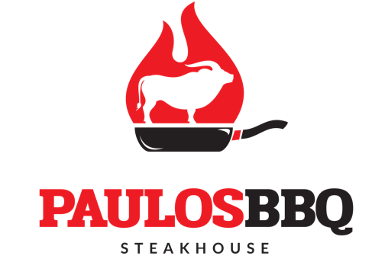
2341 Plainfield Ave, South Plainfield, NJ 07080
908-753-5252
FOOD PACKAGE #2

SALAD AND SOUP
( Included)
House Portuguese Salad
Lettuce, Tomatoes, Red Onions, Peppers, Cucumber and Olives
Caldo Verde
Potatoes and collard greens with thin sliced smoked sausage
APPETIZER
(Pre-selected Choice of Three)
Fried Calamari
Breaded Calamari rings with homemade Marinara Sauce
Garlic Shrimp
Sautéed shrimp in garlic, butter, white wine & paprika
Frango a Passarinho
Brazilian wings style, small cuts sautéed with
garlic and lime sauce
Brazilian Sausage and Yucca
Fried sliced Brazilian Sausage with fried yucca
Mozzarella Sticks
Deep fried sticks of mozzarella cheese coated in seasoned breadcrumbs
MAIN COURSE
(Pre-selected Choice of Four)
Roasted Chicken
Charcoal Grilled Chicken
Pork Spare Ribs
Slow cooked charcoal grilled spare ribs
Chicken or Beef or Mix Cubes
Sautéed Cubes in a homemade gravy with picked vegetables
Portuguese Fish Fillet
Fried hand breaded fillet of sole
Spaghetti Marinara
Spaghetti Pasta with homemade Marinara sauce
…
…

Steak with Onions
Sliced Sirloin steak sautéed with caramelized onions
Beef Ribs
Charcoal grilled three bones beef ribs
Chicken Breast in garlic or lemon sauce
Slightly breaded fried chicken breast sautéed in a sauce of choice

DESSERT
(Pre-selected Choice of One)
Homemade Brazilian Flan
Homemade Rice Pudding
Roasted Pineapple
SIDES
(Included)
Yellow Rice
Black or Red Beans
French Fries
Fried Banana or Mix Vegetables
$43.00 Per Person
Prices Subject to 20% Service Charge and Current New Jersey Sales Tax

